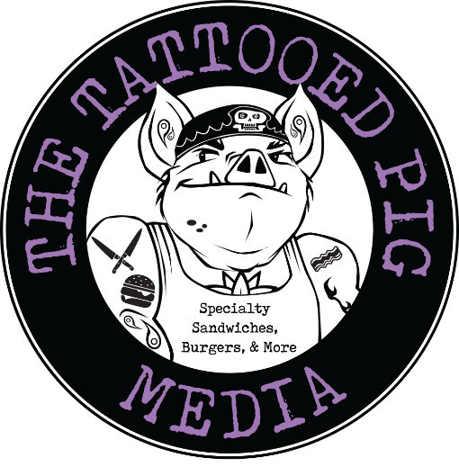
Tattooed Pig Media, Restaurant Week
Extended 4/16 – 4/20
Each meal comes with
A fresh made drink (assorted lemonades & Iced teas)
Angie’s Famous Cornbread
Choice Of BBQ Meats
Single $26 - Double $30 – Triple $35
Brisket, Pulled Pork, Chicken, Ribs, Kielbasa

Choice of 2 sides
Corn Fritters – Potato Salad – Collard Greens – French Fries – Mac & Cheese
Green Beans – Corn – Baked Beans – Pasta Salad – Apple Slaw

Choice of Dessert
Churro - Bread Pudding - banana pudding -Pie
110 s. Edgmont st. Media, Pa. 19063

